**INTRODUCTION TO DATABASE**

1)Creating a table:

Create table Student(student_id varchar(20), student_name varchar(30),  
marks number,grade varchar(2));

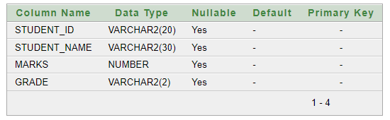

2)Imputing Data:

INSERT INTO Student (student_id, student_name, marks, grade)  
VALUES ('GA-001', 'John', 285, 'A');

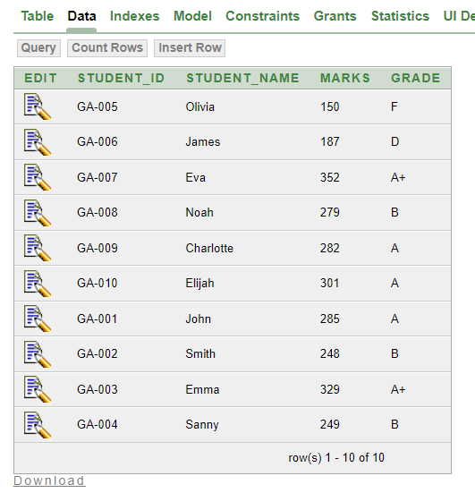

3)colum adding :

Alter table STUDENT add(Remark varchar(20));

4)Adding remark value :

update student

set remark = case

when grade = 'A' or grade = 'B' or grade = 'C' or grade = 'D' or grade = 'A+' then 'Pass'

else 'Fail'

end;

